Batch: E-2 Roll No.: 16010123325

Experiment No.___3____

Grade: AA / AB / BB / BC / CC / CD /DD

Signature of the Staff In-charge with date

Title: Study, Implementation, and Comparative Analysis of Merge Sort and Quick Sort.

Objective: To learn the divide and conquer strategy of solving the problems of different types

CO to be achieved:
CO 2 | Describe various algorithm design strategies to solve different problems and analyze Complexity.

Books/ Journals/ Websites referred:
- Ellis horowitz, Sarataj Sahni, S.Rajsekaran,” Fundamentals of computer algorithm”, University Press
- T.H.Cormen ,C.E.Leiserson,R.L.Rivest and C.Stein,” Introduction to algorithms”,2nd Edition ,MIT press/McGraw Hill,2001
- http://en.wikipedia.org/wiki/Quicksort
- https://www.cs.auckland.ac.nz/~jmor159/PLDS210/qsort.html
- http://www.cs.rochester.edu/~gildea/csc282/slides/C07-quicksort.pdf
- http://www.sorting-algorithms.com/quick-sort
- http://www.cse.ust.hk/~dekai/271/notes/L01a/quickSort.pdf
- http://en.wikipedia.org/wiki/Merge_sort
- http://www.personal.kent.edu/~rmuhamma/Algorithms/MyAlgorithms/Sorting/mergeSort.htm
- http://www.sorting-algorithms.com/merge-sort
- http://www.princeton.edu/~achaney/tmve/wiki100k/docs/Merge_sort.html

Pre Lab/ Prior Concepts:
Data structures, various sorting techniques

Historical Profile:
Quicksort and merge sort are divide-and-conquer sorting algorithm in which division is dynamically carried out. They are one the most efficient sorting algorithms.

New Concepts to be learned:
Number of comparisons, Application of algorithmic design strategy to any problem, Classical problem solving vs Divide-and-Conquer problem solving.

Algorithm Recursive Quick Sort:
void quicksort( Integer A[ ], Integer left, Integer right)
//sorts A[left.. right] by using partition() to partition A[left.. right], and then //calling itself // twice to sort the two subarrays.
{ IF ( left < right ) then
{ q = partition( A, left, right);
quicksort( A, left, q–1);
quicksort( A, q+1, right);
}
}

Integer partition(integer AT[], Integer left, Integer right)
//This function rarranges A[left..right] and finds and returns an integer q, such that A[left], ..., //A[q–1] <∼ pivot, A[q] = pivot, A[q+1], ..., A[right] > pivot, where pivot is the first element of //a[left…right], before partitioning.
{
pivot = A[left]; lo = left+1; hi = right;
WHILE ( lo ≤ hi)
{ WHILE (A[hi] > pivot) hi = hi – 1;
WHILE ( lo ≤ hi and A[lo] <∼pivot) lo = lo + 1;
IF ( lo ≤ hi) then swap( A[lo], A[hi]);
}
swap(pivot, A[hi]);
RETURN hi;
}

Derivation of best case and worst-case time complexity (Quick Sort) Algorithm Merge Sort
MERGE-SORT (A, p, r)
// To sort the entire sequence A[1 .. n], make the initial call to the procedure MERGE-SORT (A, //1, n). Array A and indices p, q, r such that p ≤ q ≤ r and sub array A[p .. q] is sorted and sub array //A[q + 1 .. r] is sorted. By restrictions on p, q, r, neither sub array is empty.
//OUTPUT: The two sub arrays are merged into a single sorted sub array in A[p .. r].
IF p < r // Check for base case
THEN q = FLOOR [(p + r)/2] // Divide step
MERGE (A, p, q) // Conquer step.
MERGE (A, q + 1, r) // Conquer step.
MERGE (A, p, q, r) // Conquer step.

MERGE (A, p, q, r)
{
n₁ ← q − p + 1
n₂ ← r − q
Create arrays L[1 . . n₁ + 1] and R[1 . . n₂ + 1]
FOR i ← 1 TO n₁
DO L[i] ← A[p + i − 1]
FOR j ← 1 TO n₂
DO R[j] ← A[q + j ]
L[n₁ + 1] ← ∞
R[n₂ + 1] ← ∞
i ← 1
j ← 1
FOR k ← p TO r
DO IF L[i ] ≤ R[ j]
THEN A[k] ← L[i]
i ← i + 1
ELSE A[k] ← R[j]
j ← j + 1

}

The space complexity of Quick Sort:
O(1)

The space complexity of Merge sort:
O(n)

Code (Quicksort)-
#include <bits/stdc++.h>
using namespace std;

int partition(vector<int> &arr, int low, int high) {
int pivot = arr[low];
int i = low, j = high;
while (i < j) {
while (arr[i] <= pivot && i <= high) {
i++;
}
while (arr[j] > pivot && j >= low) {
j--;
}
if (i < j) {
swap(arr[i], arr[j]);
}
}
swap(arr[low], arr[j]);
return j;
}

void QuickSort(vector<int> &arr, int low, int high) {
if (low < high) {
int pIndex = partition(arr, low, high);
QuickSort(arr, low, pIndex-1);
QuickSort(arr, pIndex+1, high);
}
}

int main() {
int n; cin >> n;
vector<int> arr(n);
for (int i = 0; i < n; ++i) cin >> arr[i];
QuickSort(arr, 0, n-1);
for (int i = 0; i < n; ++i) cout << arr[i] << " ";
}

Output-
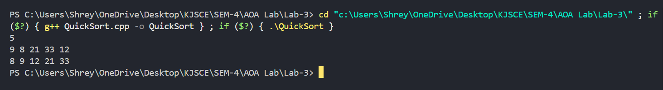
Code (Merge Sort)-
#include <bits/stdc++.h>
using namespace std;

void merge(vector<int> &arr, int low, int mid, int high) {
vector<int> temp;
int l = low, r = mid + 1;
while (l <= mid && r <= high) {
if (arr[l] < arr[r]) {
temp.push_back(arr[l++]);
} else {
temp.push_back(arr[r++]);
}
}
while (l <= mid) {
temp.push_back(arr[l++]);
}
while (r <= high) {
temp.push_back(arr[r++]);
}
for (int i = low; i <= high; i++) {
arr[i] = temp[i - low];
}
}

void mergeSort(vector<int> &arr, int low, int high) {
if (low < high) {
int mid = low + (high - low) / 2;
mergeSort(arr, low, mid);
mergeSort(arr, mid + 1, high);
merge(arr, low, mid, high);
}
}

int main() {
int n;
cout << "Enter the elements of the array: ";
cin >> n;
vector<int> arr(n);
for (int i = 0; i < n; ++i) cin >> arr[i];
mergeSort(arr, 0, arr.size() - 1);
for (int i = 0; i < arr.size(); i++) cout << arr[i] << " ";
}

Output-
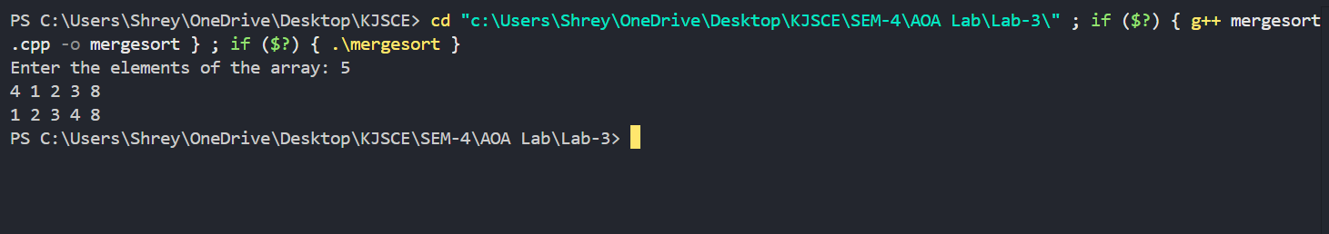

Derivation of best case and worst-case time complexity (Merge Sort)
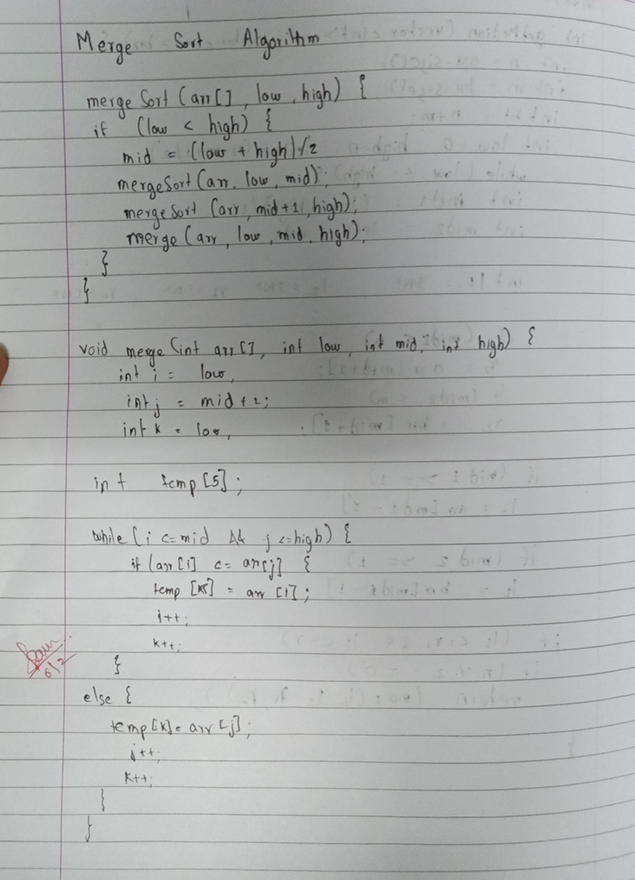

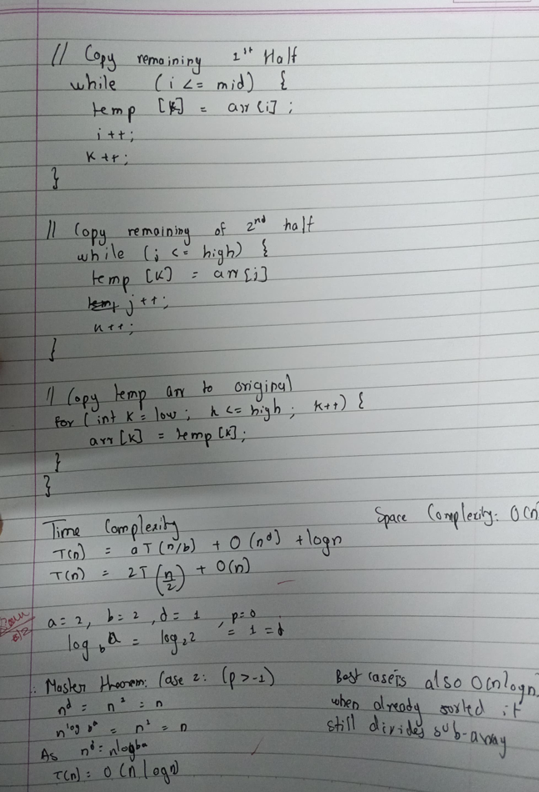

Derivation of best case and worst-case time complexity (Quick Sort)
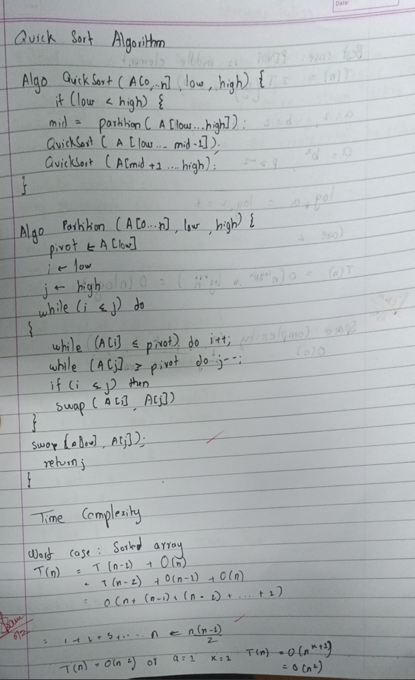

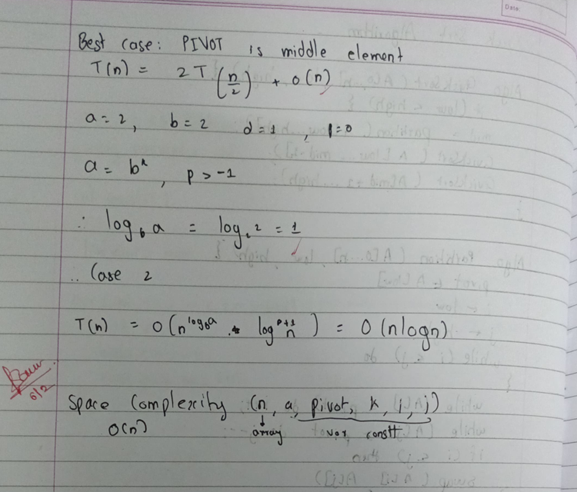

Example for quicksort/Merge tree for merge sort:
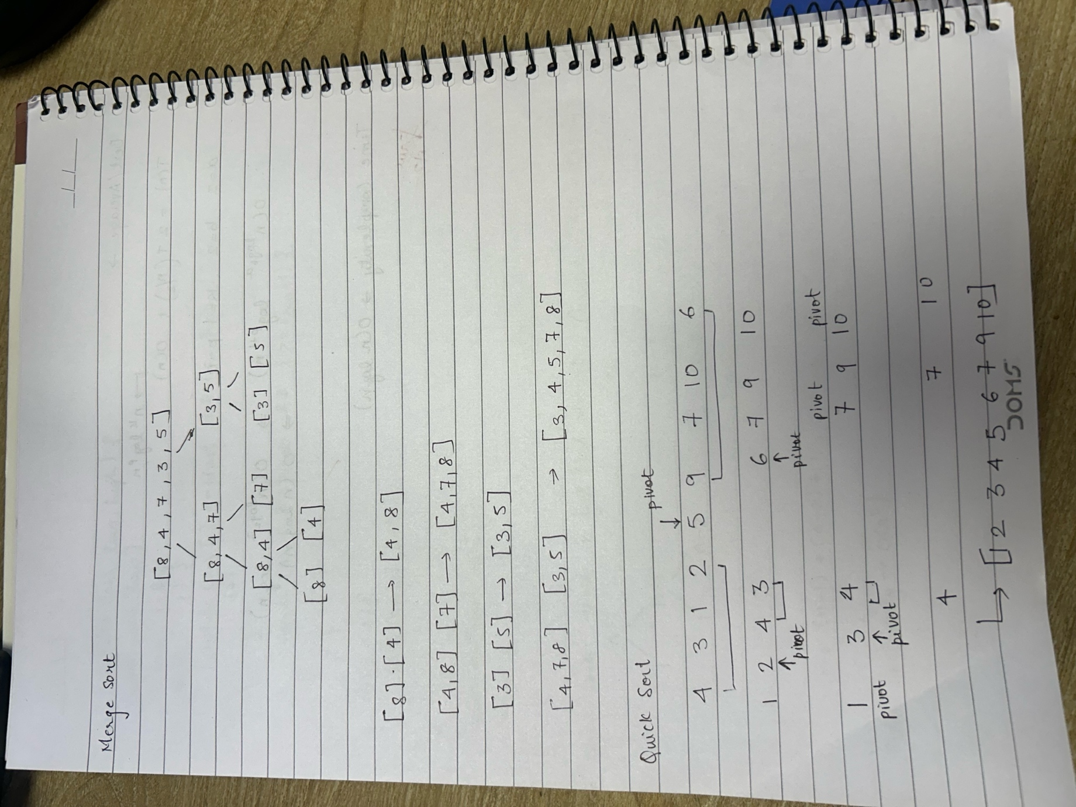

CONCLUSION:

The above experiment highlights better sorting techniques like Quick Sort, Merge Sort give complexity O(n log n) compared to the previous experiment

